2.8: From the expression for x(t), x(0) = 0, x(2.00 s) = 5.60 m and x(4.00 s) = 20.8 m. a) 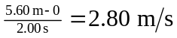 b) 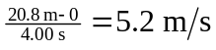 c) 